M.A.H. Maths at Home 1

Quadrilaterals

Suitable for all students
Quadrilaterals are shapes that have four straight sides.
Draw a circle with eight evenly-spaced dots round it.
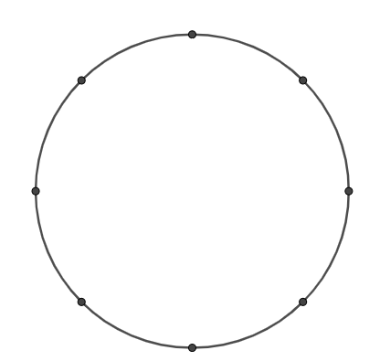 8 dots for example: 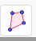
How many DIFFERENT quadrilaterals can be made by joining the dots on the circle?
(Trace around a tin to draw a new circle to try)
Can you work out the angles of all your quadrilaterals?

Please bring your ‘maths at home’ to school by Friday 31st July to be in the raffle to win a set of sharpies!
